2.抽样结果：
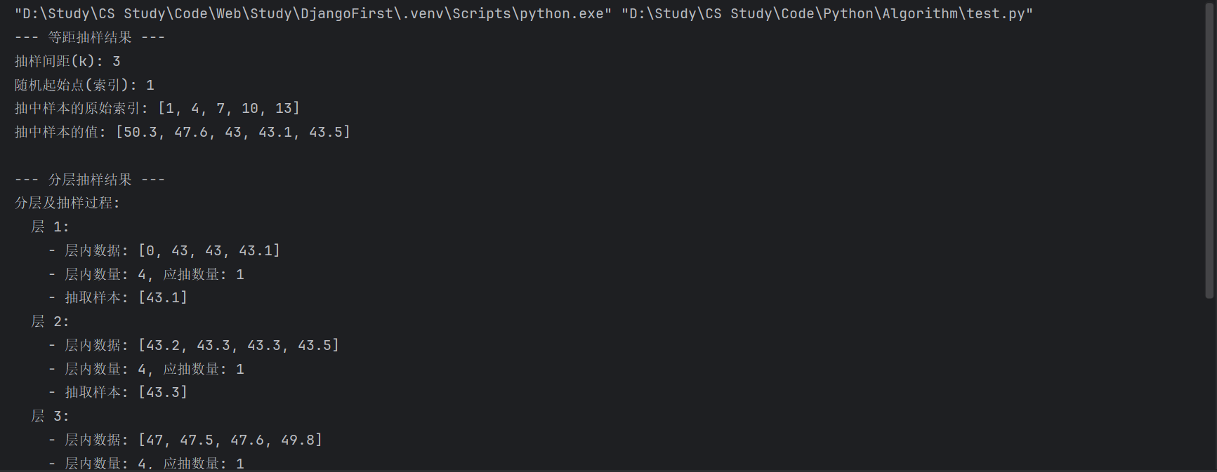
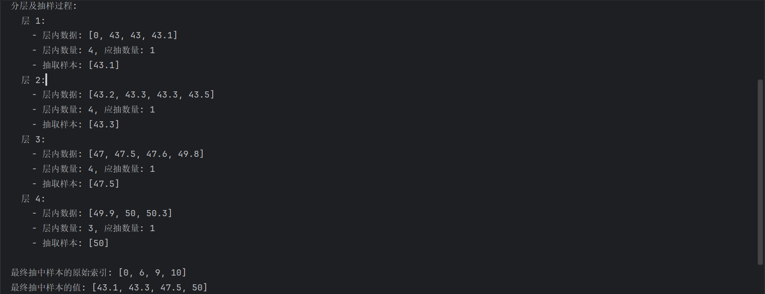
源代码：
import random

data_data = [50, 50.3, 49.8, 49.9, 47.6, 47, 47.5, 43, 43.2, 43.3, 43.1, 43.3, 43, 43.5, 0]
m, a, k = 15, 1 / 3, 4

def systematic_sampling(data, m, a):
n = int(round(m * a)) # 计算样本容量
interval = m // n
start_index = random.randint(0, interval - 1)
sample = []
sample_indices = []
for i in range(n):
index = start_index + i * interval
sample.append(data[index])
sample_indices.append(index)
return sample, sample_indices, interval, start_index

def stratified_sampling(data: list, m: int, a: float, num_strata: int):
n = int(round(m * a)) # 计算总样本容量
indexed_data = sorted(list(enumerate(data)), key=lambda x: x[1])
strata = []
strata_details = {} # 用于记录分层和抽样详情

stratum_size_base = m // num_strata
extra = m % num_strata

current_pos = 0
for i in range(num_strata):
size = stratum_size_base + (1 if i < extra else 0)
strata.append(indexed_data[current_pos: current_pos + size])
current_pos += size

final_sample_values = []
final_sample_indices = []

for i, stratum in enumerate(strata):
stratum_m = len(stratum)
stratum_n = int(round(n * (stratum_m / m)))
if stratum_n > 0:
# 从该层中随机抽取 stratum_n 个样本
stratum_sample = random.sample(stratum, stratum_n)
strata_details[f'层 {i + 1}'] = {
'层内数据': [val for idx, val in stratum],
'层内数量': stratum_m,
'分配样本数': stratum_n,
'抽取样本': [val for idx, val in stratum_sample]
}

for index, value in stratum_sample:
final_sample_values.append(value)
final_sample_indices.append(index)

return final_sample_values, final_sample_indices, strata_details

# --- 执行等距抽样 ---
syst_sample, syst_indices, interval, start = systematic_sampling(data_data, m, a)

print("--- 等距抽样结果 ---")
print(f"抽样间距(k): {interval}")
print(f"随机起始点(索引): {start}")
print(f"抽中样本的原始索引: {syst_indices}")
print(f"抽中样本的值: {syst_sample}")

# --- 执行分层抽样 ---
strat_sample, strat_indices, strat_details = stratified_sampling(data_data, m, a, k)

print("\n--- 分层抽样结果 ---")
print("分层及抽样过程:")
for name, details in strat_details.items():
print(f" {name}:")
print(f" - 层内数据: {details['层内数据']}")
print(f" - 层内数量: {details['层内数量']}, 应抽数量: {details['分配样本数']}")
print(f" - 抽取样本: {details['抽取样本']}")

print(f"\n最终抽中样本的原始索引: {sorted(strat_indices)}")
print(f"最终抽中样本的值: {strat_sample}")

